1. Write a js method, when user click on button, display random integer below it.

output console.log

Js code:

Html code:

1. Write js function to format number up to specified decimal places.

Output: html code:

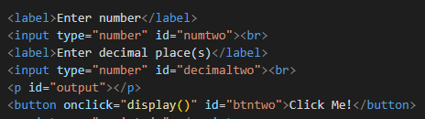

Js code:

1. Check particular sub-word exist in a string or not e.g. i am learning js: 'js' exists or not

Js code output:

1. Given year leap year or not (29 in feb)

Output:

Js code:

Html code:

1. ATM Machine and style it

**Log In Page Function Page**

**Withdraw Cash Deposit Cash**

***js code: Log in***

***ATM js code: Withdraw Cash***

***ATM js code: Deposit Cash***

**ATM HTML code:**

1. Add only even numbers in an array (array elements to be input by user)

Output:

Js code:

1. Biggest of even number in an array [10, 12, 90, 93, 707]: biggest even number is 90

Js code: console.log

1. Add two array [10,20,30] + [1,2,3]: [11, 22, 33]

Js code: console.log

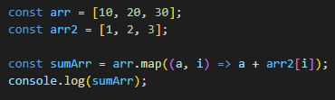

1. Reverse an array(with loops) [10, 78, 0]: [0, 78, 10]

Js code: console.log

1. Reverse a string using loops

Js code console.log

1. Remove duplicate items from an array [10, 50,20 67, 10, 20]: remove 10, 20

Js.code console.log

1. Ask user, remove a specific element from an array [12, 56, 89]: remove 1 element

Output:

Js code:

Html code:

1. Get the largest odd and even number in an array [10, 12, 900, 93, 707].

Js code: console.log

1. Take 3 inputs from user and structure them into objects.

Output:

Console.log:

Js code:

1. Create a class Car: city(),specialFeature()

name, brand, color, manufacture

console.log:

Js.code:

1. Create a class Book: type_of_book()

no. of pages, type of pages, author

console.log:

Js code:

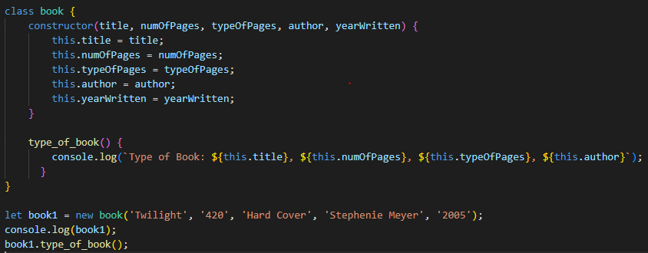

1. Create a class Animal: walk(), eat(), climb()

gender, name, disease

console.log

Js code:

1. Inheritance: parent electronics (methods: name, version, company name): childclass(laptop, ipad, mobile, tablet):

class child {

configuration()

price()

}

Console.log

js code: